MP3 File Naming System

1st # 2nd # - 3rd/4th # (Space) Title .
(All Others) (Choirs Only)
1. Choirs 1. Sunday 1. Men’s Choir Track # or Speaker
2. Inspiration 2. Monday 2. Teen Choir Forum Letter Song Title
3. Sermons 3. Tuesday 3. Adult Choir - Forum Title
4. Forums 4. Wednesday 4. Tiny Tot Choir
5. Thursday 5. Primary Choir
6. Friday 6. Junior Choir
7. Orchestra
8. Classical Siesta

MP3 File Examples:

21-01 Talk = Sunday Inspiration Hour Track 1

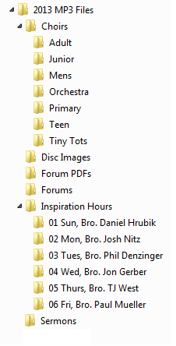
13-04 Adult Choir

42-A - Reflecting Christ in Moral Issues - Dennis Delic

31-11 Sun Sermon - Bro. Matt Ebinger

Commas and apostrophes are NOT allowed in the file name.
Also, there can only be 1 space between words/characters. This
is because the mp3 download page on website does not support it.

Use the MP3 Files to compile the:
-Inspiration Music CDs
-Choir CDs
This will utilize the Tagging Features for
CD players capable of reading CD text

Speech should be saved as a 64 kBit/s MP3
Music should be saved as a 192 kBit/s MP3

All speakers’ full names and song titles should be
acquired from the Lehman audio staff.

Google the lyrics of a song if the correct title is not available.
Commas and apostrophes are NOT allowed in the file name.
